# Answers to Component 2 on Credit Task 3

Name: Almira Putri Sandy

Student ID: 100082480

Selected Website & Link: https://www.zalora.com.my/women/

## Enhance the a one-page corporate site template/Webpage (wireframe) which you have done in Pass Task 2:

## It should contain a minimum of 5 main parts namely: corporate banner/slider, main product/service highlight, product/service features, company profile, and footer.

## There must be a minimum of 10 individual boxes in your design.

## You need to provide additional wireframe for Mobile View (use col-xs-**).

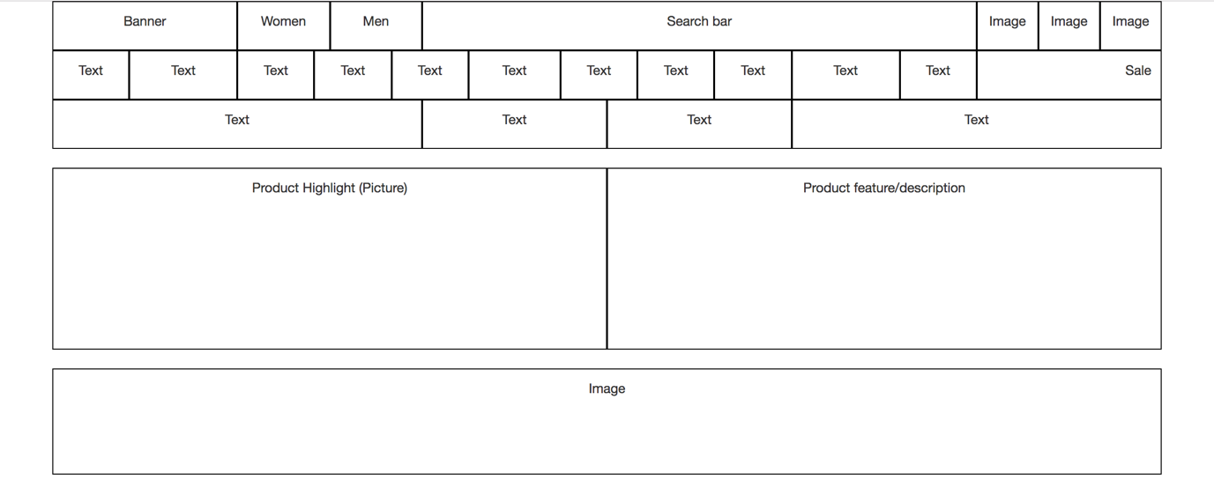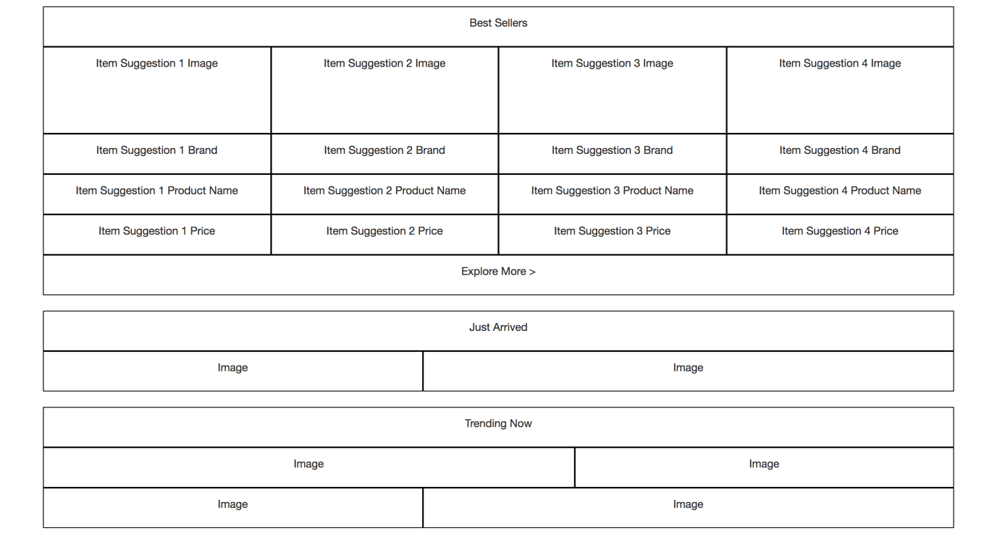**Desktop View Wireframe:**

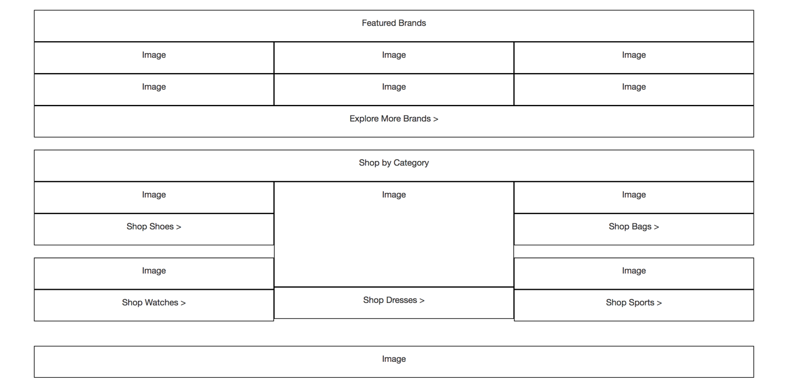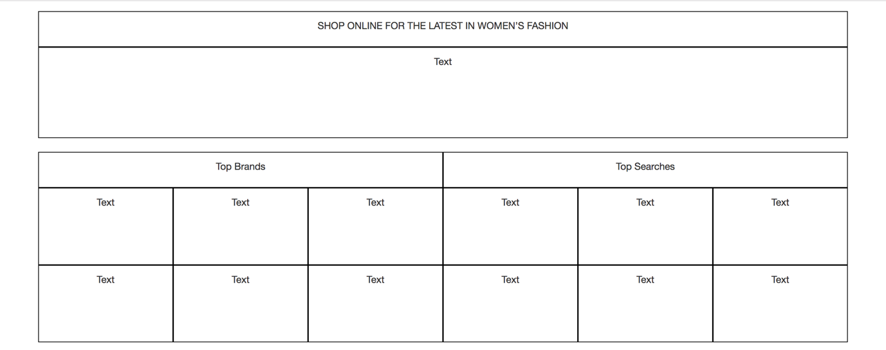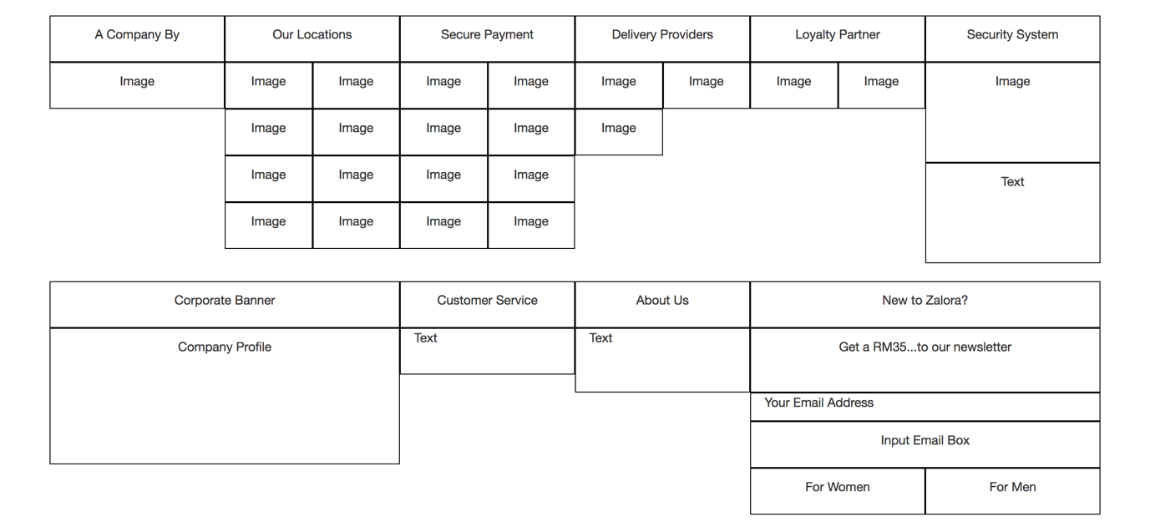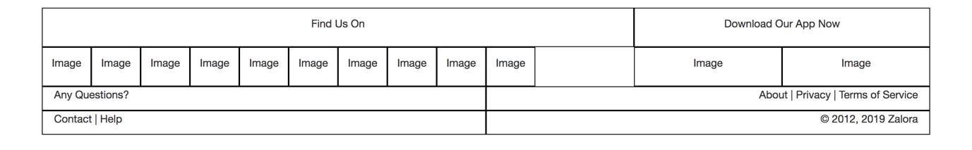

**Mobile View Wireframe:**

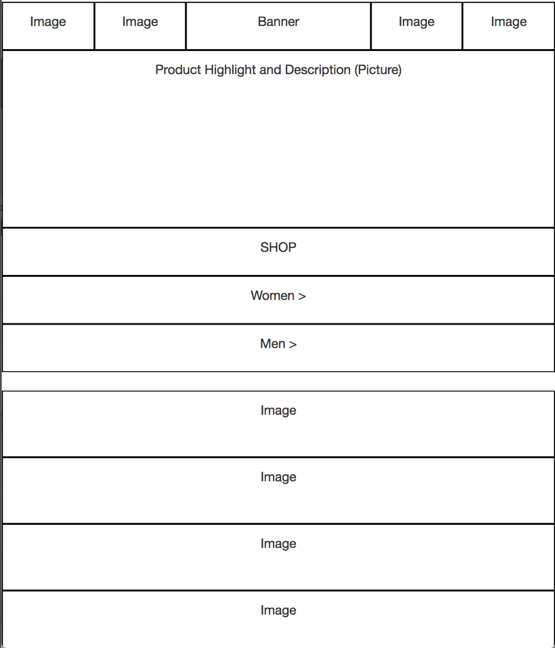

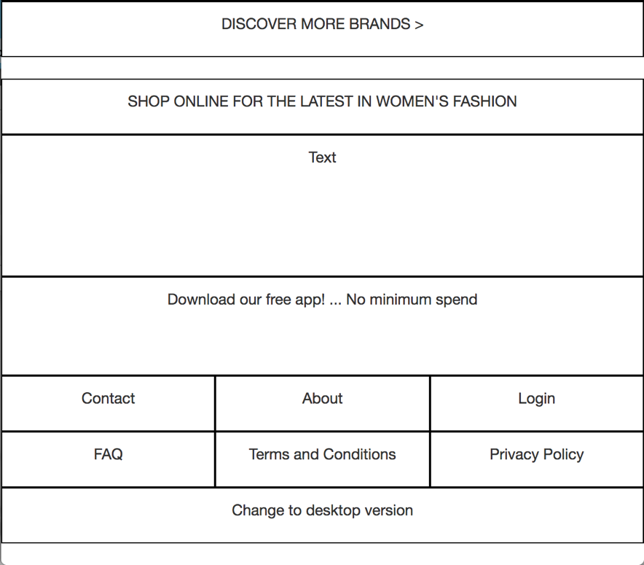

## Webpage Development Checklist & Evidences.

You are required to demonstrate your competency of website/webpage development using Bootstraps and AngularJS effectively by applying the concepts, topics and techniques learned in this unit.

|  |  |  |  |
| --- | --- | --- | --- |
| **ID** | **Criteria** | **Fulfilled (✓)** | **Evidence** |
| 1 | Effectively design and develop the webpage using Bootstraps’s Grid Layout | **✓** | Every element in this mock-up Zalora website uses bootstrap’s grid system. They are contained in a container and are divided into columns. Some of them are nested row-columns. |
| 2 | Enable menu toggle in mobile view | **✓** | Resizing the screen from desktop to mobile will change the layout of the navigation    Figure 1: Mobile menu    Figure 2: Desktop menu |
| 3 | Effectively applies at least two other Bootstraps components i.e. carousel / jumbotron / table / accordion / sliders/ glyphicons / modal box / etc… | **✓** | Figure 3: Bootstrap Carousel  Figure 4: Bootstrap Jumbotron |
| 4 | Webpage is well rendered in both mobile and desktop view | **✓** | Resizing the screen from desktop to mobile will change the layout of the website to mimic the mobile view of the actual website |
| 5 | Effective use of AngularJS’s common directive & filters | **✓** | Every repeating element, such as the menu, or the “Top Brands” and “Top Searches” list was using data-ng-repeat, and some text that was required to be uppercase, such as the text in the footer, was using the uppercase filter    Figure 5: "Find us on" and "Download our app now" used uppercase filter    Figure 6: The list of brands and searches used data-ng-repeat |
| 6 | Effective use of AngularJS’s controller | **✓** | The entire website is controlled using 1 controller |
| 7 | Effective use of custom filter and/or custom directive | **✓** | The products shown in the carousel was developed using custom directive |
| 8 | Appropriately store webpage content/data using array or JSON object and render to the view with proper data-binding techniques | **✓** | Figure 7: Data stored as objects    Figure 8: Images |
| 9 | Webpage must pass HTML validation with no errors and warnings | **✓** | Figure 9: HTML Validated based on NU Markup Checker |
| 10 | Webpage must comply with WCAG 1.0 (Level A) with no known problem – use Accessibility Check (achecker) | **✓** |  |
| 11 | **[Optional]** Webpage must comply with WCAG 2.0 (Level AA with no known problem – use Accessibility Check (achecker) |  |  |
| 12 | Achieved 80% similarity from the selected website | **✓** | Figure 10: Real Zalora Website      Figure 11: My Website |
| 13 | Appropriate section for acknowledgement and reference to the original website. | **✓** |  |